Deliverable #1  (C-SW312) | Course: Introduction to Software Engineering  Fall 2026

Technical Report
Project 25: Independent Living Support for Elderly People
Client: Sanad Home Care Services | Founder: Dr. Hoda Fakhry
Name | Student ID | Role
Mohamed Elkersh | 24-101277 | Team Leader
Moataz Wael | 24-101094 | Team Member
Abdelrahman Maged | 24-101540 | Team Member
Omar Mohamed | 24-101139 | Team Member
Ismail Ayman | 24-101244 | Team Member
Contents
Section | Location
1. System Vision Document | Page 2
2. Stakeholder Identification | Page 3
3. Functional Requirements | Page 4
4. Requirements Elicitation Techniques | Page 5
5. Interview Agendas | Page 6
6. Questionnaire Design | Page 8
7. Workflow Documentation | Page 9

1. System Vision Document
Project: Sanad Independent Living Support Platform
1.1 Problem Description
Many elderly residents in Cairo live alone while their families reside abroad or in other cities. Families constantly worry about health emergencies, yet seniors firmly reject indoor cameras to protect their privacy and dignity. Sanad Home Care Services also struggles with nighttime false alarms, unannounced caregiver visits startling seniors, tedious documentation, and residential power outages. To solve these challenges, Sanad requires a unified platform connecting members, families, and caregivers through ambient IoT sensors, an Arabic smart speaker, battery-backed hubs, an Android caregiver application, and a family web portal with real-time emergency alerts and daily aggregated summaries.
1.2 System Capabilities
1. Ambient Non-Camera Monitoring: Motion and door sensors track daily living routines (wake, meals, movement) without camera intrusion.
2. Arabic Smart Speaker Check-in: Interactive speaker with customizable voice speed/pitch verifies safety in Arabic upon detecting unusual events.
3. Automated Tiered Escalation: If the member does not respond within 5 minutes, calls family; if unreachable after 10 minutes, dispatches the nearest caregiver.
4. Direct Emergency Fall Dispatch: Calls emergency medical services (123) within 2 minutes of a detected hard fall and notifies family in parallel.
5. Morning Inactivity Protection: Enforces a wake-up inactivity check (addressing the missed-fall incident) to detect undiscovered morning emergencies.
6. Privacy Controls & Away Mode: Members can pause monitoring for up to 24 hours at will and enable Away Mode during travel.
7. Caregiver Matching & 10-Hr Limit: Matches visits by district, language, and skill, while strictly enforcing a 10-hour daily work limit.
8. Mobile Verification & Short Notes: Caregivers receive visit schedules, check in/out on Android using codes, members receive 24-hour advance notice via the smart speaker, and caregivers submit concise visit notes.
9. Time-Zone-Aware Family Dashboard: Displays daily red/green summaries in the relative's local time zone with family voice messaging.
10. 8-Hour Offline Resiliency: Home hubs provide 8-hour battery backup during electrical power cuts to maintain uninterrupted monitoring.
1.3 Business Benefits
• Peace of Mind with Dignity: Families receive timely reassurance while seniors maintain independence without cameras.
• Rapid Emergency Care: Targeted 2-minute emergency dispatch for falls and under 45-minute caregiver arrival in Cairo.
• Reduced False Alarms: Two-way Arabic voice check-in resolves routine variances before disturbing family members.
• Scalable Operations: Automated matching, code check-in, and concise reporting support scaling from 50 to 500 homes.
1.4 Key Constraints and Assumptions
• Consent & Privacy: Member holds sovereign consent, reviewed every 6 months; monitoring can be paused up to 24 hrs.
• Response Standards: Emergency services called within 2 mins of hard fall; urgent Cairo caregiver arrival target: 45 mins.
• Hardware & Power: 6–10 sensors per home; hub provides 8-hr battery backup; fewer than 1 false alarm per 50 fall detections.
• Caregiver Work Limits: Android caregiver app; mandatory 10-hr daily work limit; annual background check renewals.
2. Stakeholder Identification
2.1 Four Stakeholder Categories (Chapter 2)
Stakeholders are categorized into four standard groups to understand who operates, governs, receives, or supports the system:
1. Internal Operational: Staff using the system in daily workflows (Care Coordinator Mona Sabri, Caregiver Lead Ahmed Nasser, Field Caregivers).
2. Internal Executive: Management governing organizational strategy and finance (Founder and Director Dr. Hoda Fakhry).
3. External Operational: Individuals outside Sanad directly receiving care or updates (Elderly Member Hajja Fatma, Family Contact Nadia Morsy).
4. External Executive: External technical partners and statutory/emergency authorities with technical or regulatory obligations (Sensor Tech Partner Eng. Karim Ezz, Emergency Services).
2.2 Stakeholder Summary Table
Stakeholder | Category | System Role | Key Interests & Priorities
Dr. Hoda Fakhry  Founder & Director | Internal  Executive | Project sponsor and executive owner. | Ensuring member safety and dignity; tracking service KPIs (response time, false alarms); managing billing and caregiver payroll.
Mona Sabri  Care Coordinator | Internal  Operational | Onboards members and manages routines. | Conducting consent video calls (6-month renewal); setting routine profiles (wake, meals); handling anomaly escalations and Away Mode.
Ahmed Nasser  Caregiver Lead | Internal  Operational | Coordinates field staff across Cairo. | Matching caregivers by district, language, and skill; enforcing the 10-hr daily limit; tracking visit completions and background checks.
Field Caregivers | Internal  Operational | Deliver scheduled care and urgent visits. | Receiving visit schedules; members receive 24-hour advance notice; quick mobile check-in/out via code; concise visit notes.
Hajja Fatma  Elderly Member | External  Operational | Lives independently at home. | Absolute absence of cameras; clear Arabic speaker voice at lower pitch/speed; controlling 24-hr privacy pause and Away Mode.
Nadia Morsy  Family Contact | External  Operational | Daughter abroad monitoring mother. | Viewing daily red/green summaries in her local time zone (e.g., Dubai, Canada); immediate alert notifications; booking caregiver visits.
Eng. Karim Ezz  Tech Partner | External  Executive | Provides sensors and home hubs. | Reliable sensor event delivery within 5 seconds; hub battery health during power cuts; fall detector accuracy and daytime wear reminder rules.
Emergency Services  (123) | External  Executive | Receives direct emergency dispatch (123) on hard falls. | Accurate, timely fall dispatch; minimal false dispatches.

3. Functional Requirements
The following 12 functional requirements describe the observable behavior and business rules of the Sanad platform, incorporating core project requirements as well as critical operational rules from Sanad's incident reports and care standards:
Req ID | Requirement Name | System Observable Behavior & Business Rules
REQ-01 | Member Profiles & 6-Month Consent | The system shall maintain member routine profiles (wake, meal, medication times) and enforce a mandatory informed consent review every 6 months.
REQ-02 | sensor monitoring | The system shall capture movement and door opening events using non-camera IoT sensors, strictly prohibiting video surveillance.
REQ-03 | Arabic Speaker Check-in | When unusual activity occurs, the system shall ask the member if they are safe in clear Arabic (adjustable pitch/speed). If confirmed within 5 minutes, the alert closes.
REQ-04 | Tiered Anomaly Escalation | If the member does not respond after 5 minutes, the system shall call family contacts in priority order; if unreachable after 10 minutes, it shall dispatch the nearest caregiver.
REQ-05 | Direct Emergency Fall Dispatch | Upon detecting a hard fall, the system shall call emergency medical services (123) within 2 minutes and notify family contacts concurrently.
REQ-06 | Morning Inactivity Detection Rule | The system shall enforce a morning inactivity check (based on the missed-fall incident); if no kitchen movement is detected by the routine cutoff time, it initiates check-in and escalation.
REQ-07 | Privacy Pause & Away Mode | The system shall allow members to pause monitoring for up to 24 hours at will, and provide an 'Away Mode' to suppress routine alerts while traveling.
REQ-08 | Battery Backup | The system shall monitor hub battery status during power cuts and issue speaker reminders when the fall pendant is charging or unworn during daytime hours.
REQ-09 | Caregiver Matching & 10-Hr Limit | The system shall match visits by district, language, and skills, while strictly blocking assignments exceeding 10 daily work hours per caregiver.
REQ-10 | Mobile Code Check-in & Short Notes | Caregivers shall validate arrival and departure on Android phones using unique verification codes and submit concise, structured visit notes.
REQ-11 | Time-Zone-Aware Family Dashboard | The family portal shall show daily red/green summaries adjusted to the relative's local time zone (e.g., Dubai, Canada) and allow sending audio messages to the speaker.
REQ-12 | Advance Visit Notification | The system shall notify the member via the Arabic smart speaker at least 24 hours before each scheduled caregiver visit to prevent surprise arrivals.
4. Requirements Elicitation Techniques
To gather comprehensive, accurate, and realistic requirements for the Sanad platform, four complementary elicitation techniques were selected. Each method matches the operational context and communication needs of specific stakeholder groups:
4.1 Semi-Structured Interviews
Dr. Hoda Fakhry (Founder & Director) and Mona Sabri (Care Coordinator)
Justification: Semi-structured interviews combine predefined core questions with the flexibility to explore emerging topics. This approach was essential for understanding complex organizational policies, such as how the coordinator balances family anxiety with member privacy, and defining legal boundaries for emergency medical dispatch.
4.2 Targeted Questionnaires
Sanad Field Caregivers
Justification: Caregivers work across various Cairo neighborhoods on tight visit schedules. A structured questionnaire collects quantitative and qualitative feedback on mobile app usability, documentation time, and schedule fairness without interrupting their daily care responsibilities.
4.3 Document Analysis
Sanad Care Charter, Incident Report: Missed Fall, and Device & Platform Memo
Justification: Analyzing existing organizational records revealed critical operational rules and past failure points. For example, the September incident report of a bathroom fall directly motivated the morning-inactivity escalation rule and fall detector daytime wear reminders, while the Care Charter provided the 2-minute emergency dispatch standard and the 10-hour caregiver work limit.
4.4 Contextual Field Observation
Home hub and sensor installation; in-home caregiver assistance visits
Justification: Directly observing installation workflows and home visits exposed practical behavioral needs that users rarely express in interviews. Observation highlighted that seniors often experience age-related high-frequency hearing decline, proving that smart speaker prompts must offer adjustable pitch and speech speed in Arabic, and confirmed that seniors get startled if visits occur without 24-hour advance notice.
5. Interview Agendas
5.1 Agenda 1: Internal Operational Stakeholder
Interviewee: Mona Sabri (Care Coordinator) | Interviewers: Systems Analysis Team
Date: Tuesday, October 20, 2026 | Time: 10:00 AM – 10:45 AM (45 min) | Location: Sanad Operations Office
Objective: Understand member onboarding, routine profile configuration, daily anomaly handling, and caregiver dispatch procedures.
Time | Agenda Item | Discussion Topics & Specific Questions
10:00–10:05  (5 min) | Introduction | State the interview purpose, introduce team roles, and outline discussion topics.
10:05–10:20  (15 min) | Onboarding & Routine Setup | • Open-ended: How do you conduct the onboarding video call to capture member consent and record routine wake/meal times?  • Closed-ended: Is member consent stored as an audio-video recording, a signed electronic form, or both?  • Closed-ended: Does the system automatically flag member profiles for consent re-verification every 6 months?
10:20–10:35  (15 min) | Anomaly Rules & Privacy Settings | • Open-ended: How do you distinguish between an elderly member simply sleeping late and a genuine inactivity emergency?  • Closed-ended: What is the exact morning routine cutoff time for kitchen sensor movement checks (e.g., 11:30 AM or 12:00 PM)?  • Open-ended: What happens if a member travels or leaves home for a day without activating Away Mode?
10:35–10:45  (10 min) | Caregiver Dispatch & Wrap-up | • Closed-ended: If family members do not answer within 10 minutes, what is the maximum time a dispatched caregiver has to reach the Cairo residence (45 min)?  • Summary: Review captured requirements and schedule follow-up verification.

5. Interview Agendas (Continued)
5.2 Agenda 2: Internal Executive Stakeholder
Interviewee: Dr. Hoda Fakhry (Founder & Director) | Interviewers: Systems Analysis Team
Date: Wednesday, October 21, 2026 | Time: 1:00 PM – 1:40 PM (40 min) | Location: Sanad Executive Office
Objective: Clarify organizational privacy boundaries, emergency dispatch protocols, caregiver work caps, and executive reporting needs.
Time | Agenda Item | Discussion Topics & Specific Questions
1:00–1:05  (5 min) | Introduction | Align project goals with Sanad's corporate vision and review meeting agenda.
1:05–1:20  (15 min) | Privacy Governance & Family Access | • Open-ended: How should the platform resolve disputes when family members demand detailed, minute-by-minute sensor access against the senior's wishes?  • Closed-ended: Does Sanad policy mandate that family portals only show aggregated daily summaries (green/red indicators) by default?  • Closed-ended: Should the system suspend non-emergency monitoring if 6-month consent renewal is refused?
1:20–1:30  (10 min) | Emergency Dispatch & Work Limits | • Closed-ended: Is emergency medical services (123) dispatched directly within 2 minutes of a hard fall without waiting for family approval?  • Closed-ended: Must the scheduling engine strictly prevent any caregiver from exceeding 10 working hours per day?  • Closed-ended: Does the platform track annual background check renewals for all caregivers?
1:30–1:40  (10 min) | Executive Analytics & Growth | • Open-ended: What key performance indicators do you require on your monthly management dashboard (e.g., false alarm rates, average response time, caregiver ratings)?  • Closed-ended: Is the 5-month timeline for the initial 50-home Cairo pilot fixed?
6. Questionnaire Design
Sanad Field Caregiver Operational Questionnaire
Target Audience: Sanad In-Home Caregivers and Field Care Staff
Purpose: This questionnaire investigates caregivers' daily shift workload, mobile application usability, documentation time, and schedule communication to guide the design of Sanad's Android caregiver mobile application.
Part I: Shift Profile and Workload
1. On average, how many home visits do you complete in a single shift? [ ] visits
2. Approximately how many minutes do you spend filling out the visit report after each visit? [ ] minutes
3. In a typical week, how often do you arrive at a home to find the member unaware of the visit? [ ] times
4. How many hours do you usually work per day, including travel time between homes? [ ] hours
5. How often in a typical week do you experience mobile app issues (freezing, login delays, connectivity)? [ ] times
Part II: Usability and Work Experience (7-Point Likert Scale)
Please rate your agreement: 1 = Strongly Disagree | 4 = Neutral | 7 = Strongly Agree
Statement | 1 | 2 | 3 | 4 | 5 | 6 | 7
1. Completing visit reports takes too much time away from caring for members. | [ ] | [ ] | [ ] | [ ] | [ ] | [ ] | [ ]
2. Members are usually informed about my visit before I arrive. | [ ] | [ ] | [ ] | [ ] | [ ] | [ ] | [ ]
3. Assigned home visits match my specific language skills and care experience. | [ ] | [ ] | [ ] | [ ] | [ ] | [ ] | [ ]
4. Checking in and out with verification codes is quick and easy on my phone. | [ ] | [ ] | [ ] | [ ] | [ ] | [ ] | [ ]
5. Daily schedules allow sufficient travel time without exceeding the 10-hour limit. | [ ] | [ ] | [ ] | [ ] | [ ] | [ ] | [ ]
Part III: Open-Ended Questions
1. What main difficulties do you face when checking in to a visit or submitting your visit notes?
____________________________________________________________________________________________________
2. What specific features or improvements would you like to see in the new mobile app to help your daily routine?
____________________________________________________________________________________________________
7. Workflow Documentation
Activity Diagrams model the flow of control, sequential activities, decision points, and cross-functional swimlanes across system actors. The two complex business processes below have been modeled using standard UML activity notation.
7.1 Workflow 1: Sensor Anomaly Detection and Emergency Escalation
This workflow models how the Sanad platform processes incoming sensor events, separates direct hard-fall emergencies from daily routine variances, and handles tiered escalation across the smart speaker, family contacts, and field caregivers.
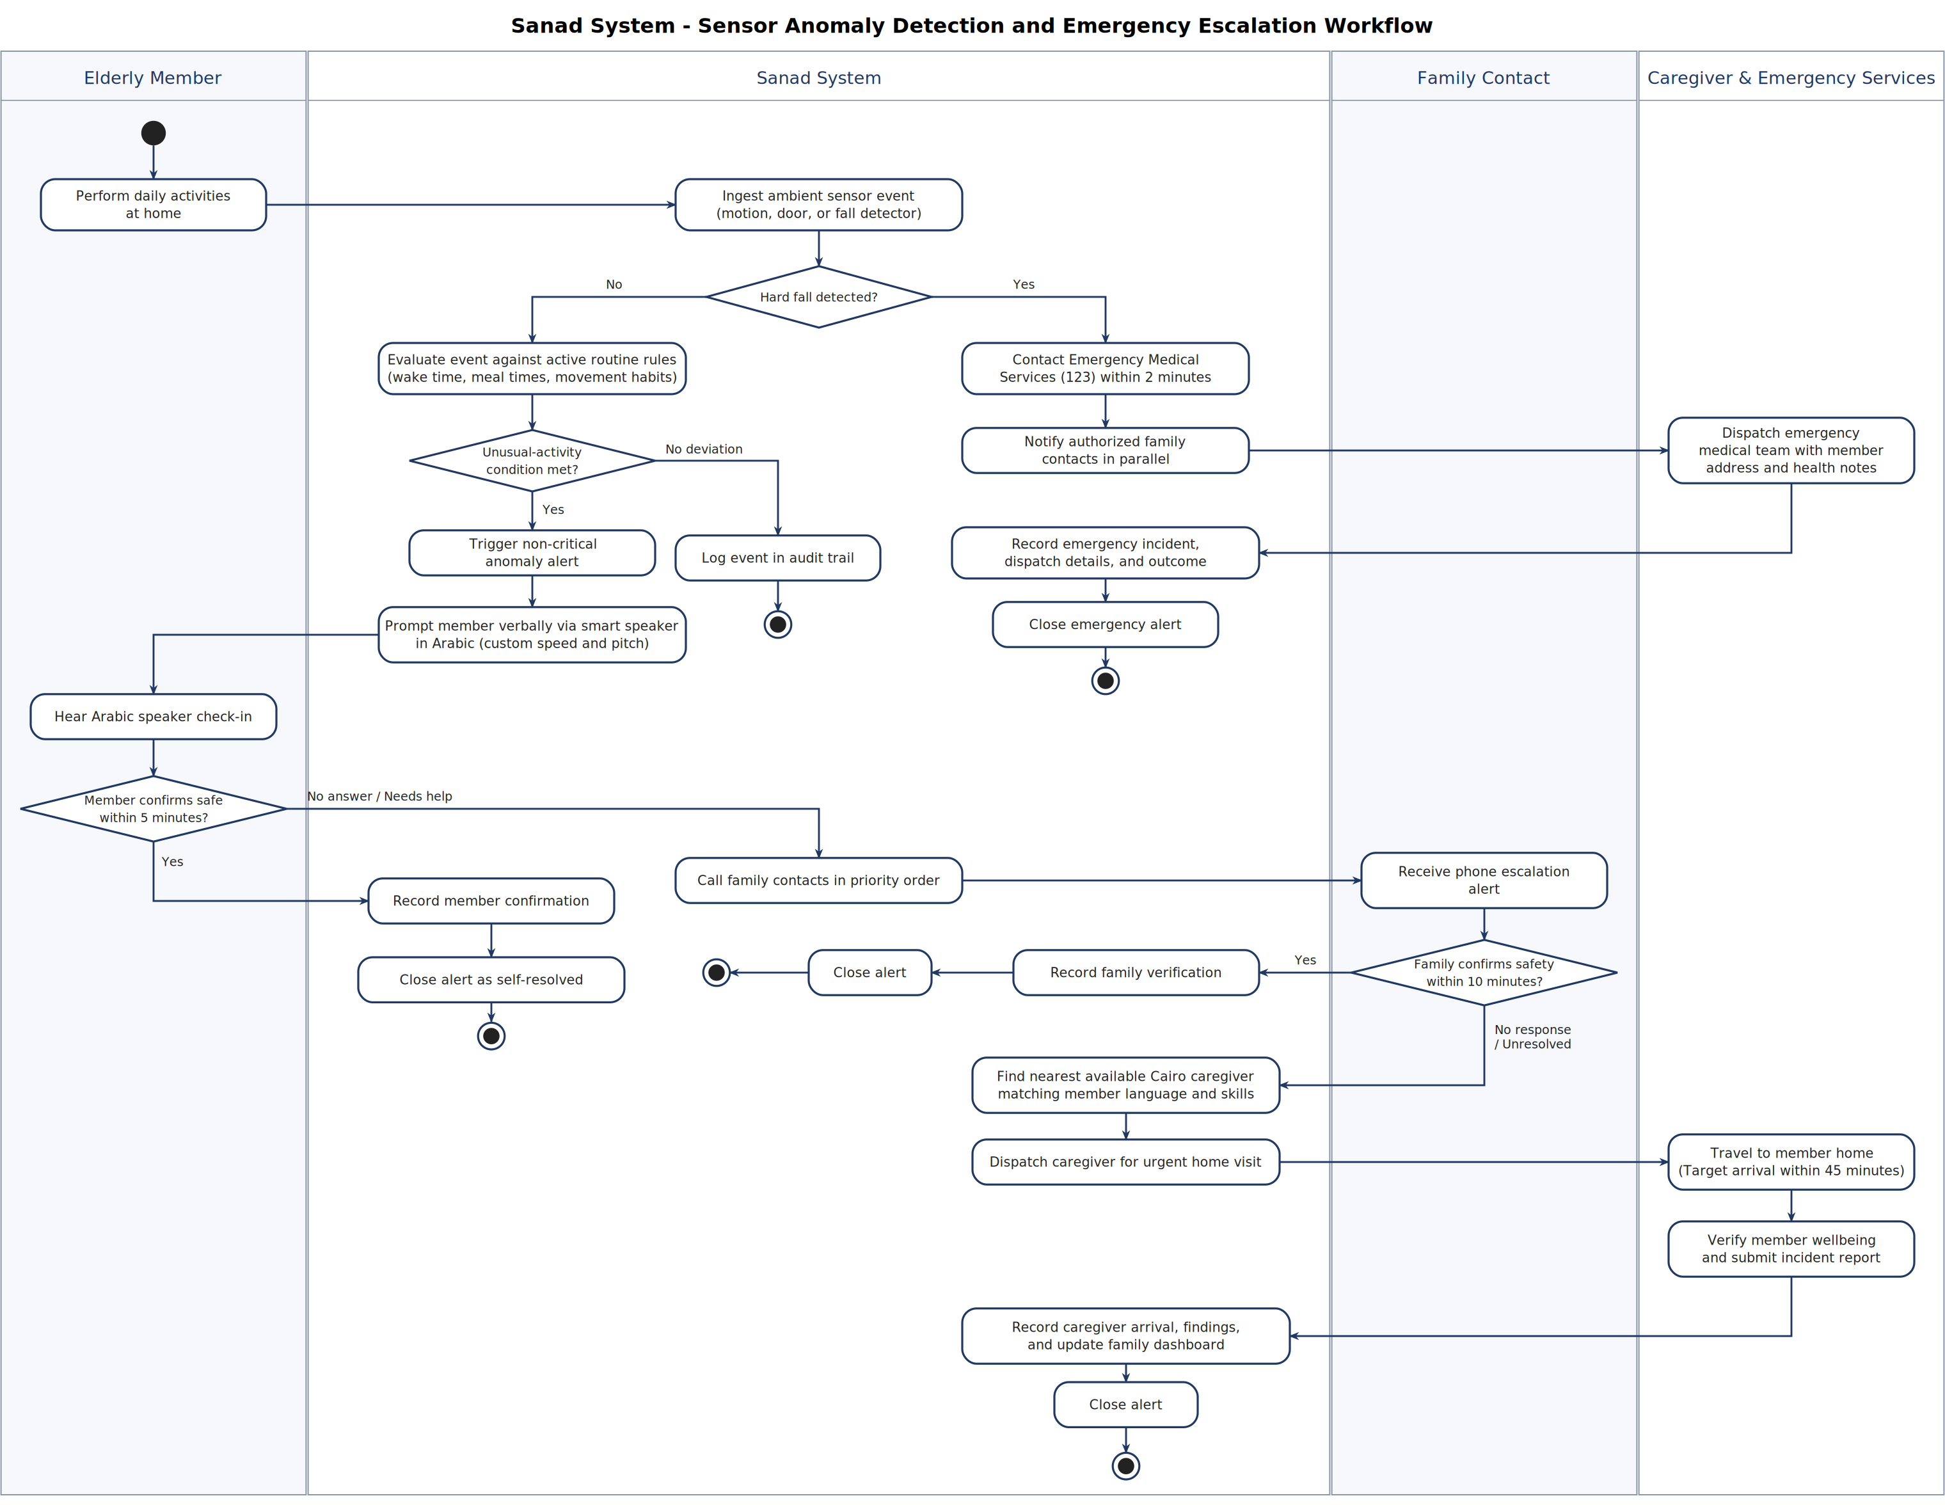
Figure 1: Sensor Anomaly Detection and Emergency Escalation Activity Diagram
Step-by-Step Workflow Explanation:
• Event Ingestion: Ambient IoT sensors (motion, door, fall pendant) capture events and send data through the home hub to the Sanad system.
• Hard Fall Decision: If a hard fall is detected, the system immediately contacts emergency services (123) within 2 minutes and alerts family contacts in parallel.
• Non-Critical Anomaly: If unusual inactivity occurs, the Arabic smart speaker asks the member if they are okay using configured voice speed and pitch.
• Member Confirmation: If the member responds within 5 minutes confirming safety, the alert is logged and closed.
• Family Escalation: If no response after 5 minutes, the system calls family contacts in prioritized order. Family has 10 minutes to verify safety.
• Caregiver Dispatch: If family does not respond within 10 minutes, the nearest available caregiver is dispatched to the home (Cairo target: within 45 minutes).
7.2 Workflow 2: Caregiver Visit Scheduling and Execution
This workflow details the complete operational lifecycle of a scheduled caregiver visit, from initial booking request and constraint validation to advance reminder notification, code check-in/out, and payroll/billing updates.
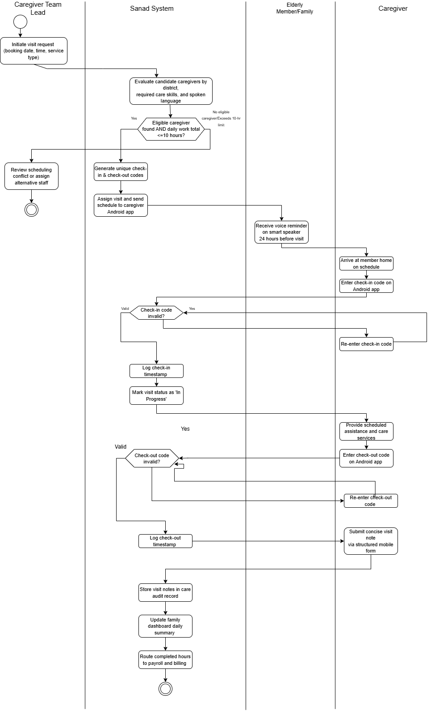
Figure 2: Caregiver Visit Scheduling and Execution Activity Diagram
• Visit Request: The Caregiver Team Lead or family requests a care visit specifying date, time, and service type.
• Constraint Matching: The Sanad platform evaluates candidate caregivers by Cairo district location, care skills, and language.
• 10-Hour Daily Limit Check: The system verifies that the assignment will not cause the caregiver to exceed 10 daily work hours. If exceeded, a new schedule is requested.
• 24-Hour Advance Reminder: The smart speaker automatically plays a reminder for the member one day before the visit, preventing surprise arrivals.
• Arrival & Code Check-in: The caregiver arrives and enters a check-in code on the Android app. The system validates the code and logs the check-in time.
• Care Delivery & Checkout: The caregiver completes the visit, enters the checkout code, and submits a concise visit note.
• Record Synchronization: The system automatically updates the family dashboard with a daily summary and updates payroll and billing records.

